**ENSF-381**: **Full Stack Web Development Laboratory**

**Lab02**

**Section: L01**

**Group information:**

Jacob Plourde (30241981)

Dave Burgoin (30214909)

**GitHub Link:** https://github.com/Jacobplo/ensf381-lab02

**Exercise 1 Output Screenshot:**

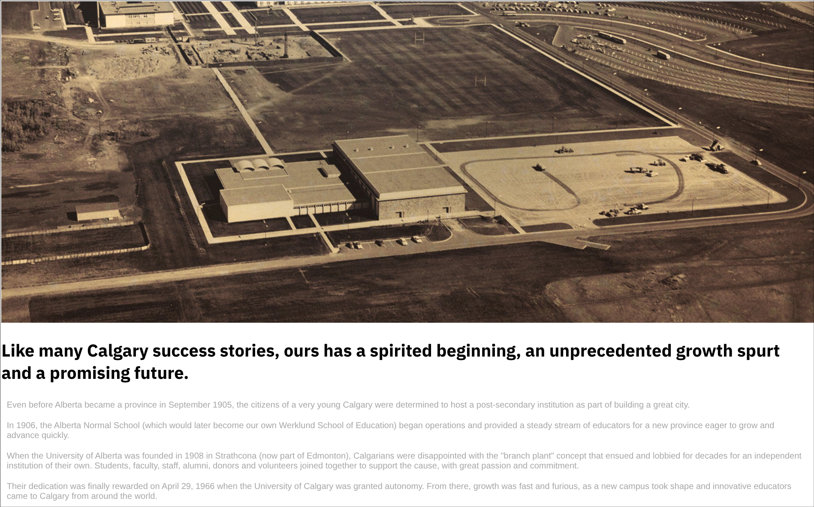



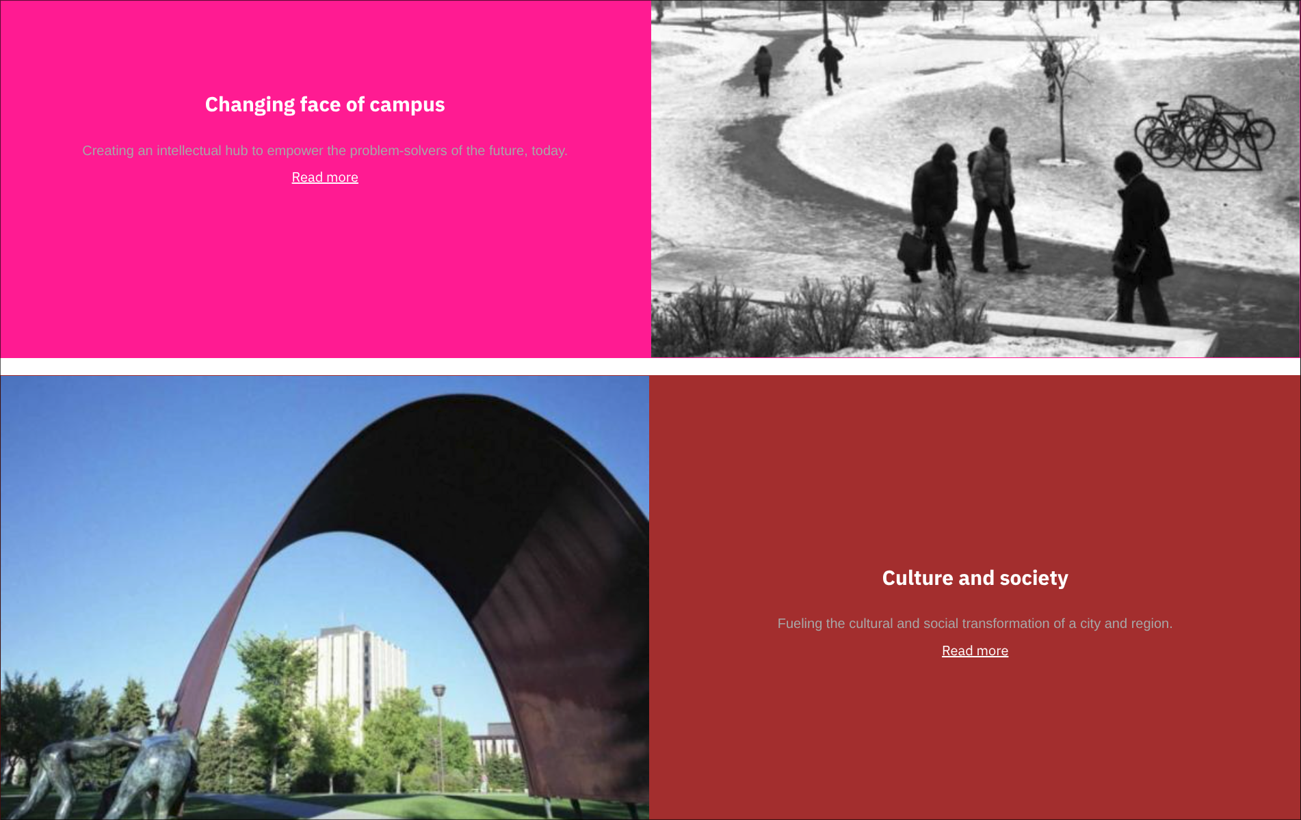

**Exercise 2 Output:**

Screenshot from step 6:



**S**creenshot from step 8:

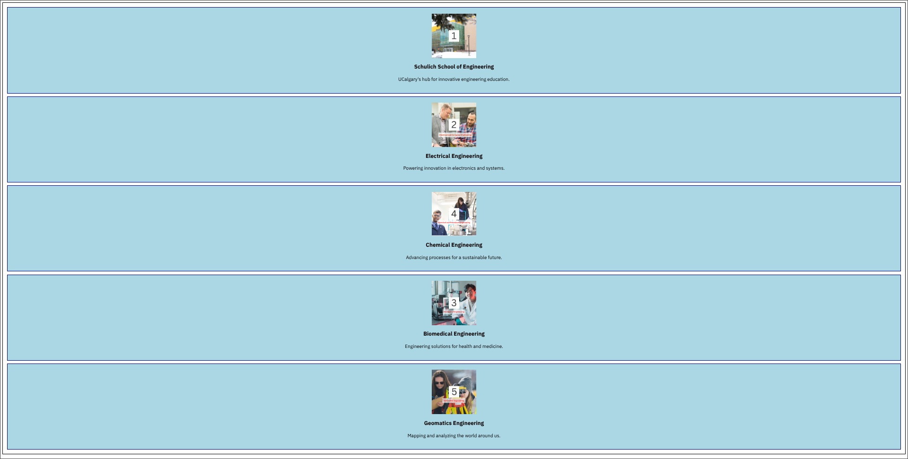  
  
**Two** Screenshots from step 9:

Row reverse:



Column reverse:

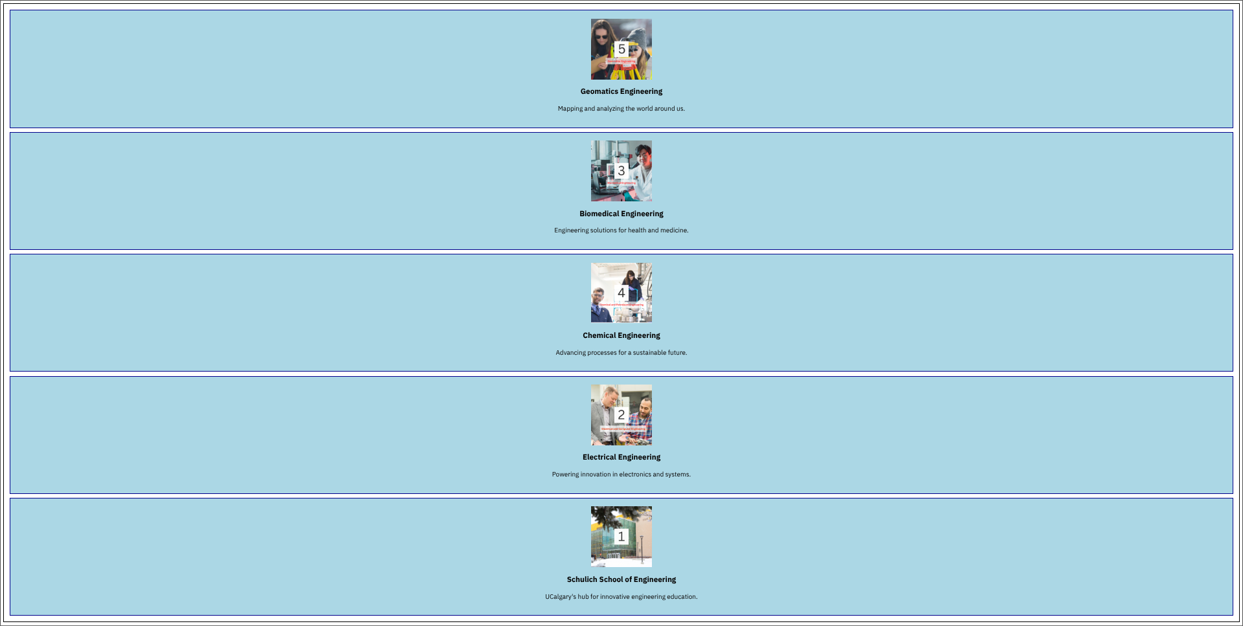

Screenshot from step 12:



Screenshot from step 14:



Screenshot from step 16:



**Exercise 3 Output Screenshot:**

